Peer Evaluation for Lab 4 – Chapter 12
Your name: (Your lab is the one being evaluated) | Will Schultz
Name(s) of peer evaluator(s) | Kaiser
Date: | 5/23/2018

Instructions
You should have already completed Lab 4. After you and a peer have evaluated your work, you will submit this evaluation along with screen shots and source code indicated in moodle. You may make corrections to your work as a result of the evaluation.
In Class Exercises – Customer Class – Exercise 12.1 (1 – 4)
Completed Customer Class?  - Instance variables are camelCase and private?  - Implements all properties/methods in the specification? Implements both property get and set? Property/Method names are TitleCase? Properties/Methods are public?  - Completed Customer Tests? Tests all properties and methods in the class? Screen shot is included?  - Created a class diagram in visual studio? Screen shot included?  - Source code includes Customer class as well as test program? | Yes  Yes  Yes  Yes  The class diagram is not from VS  yes
One thing that you learned from writing and testing the class:
I learned a lot from this lab. I learned how to create a class in C#, the different things that make up a class, and how to write a console app to test my classes.

Something that you’d like to continue working on:
I would like to continue to work on everything! There is a lot of information here and I don’t 100% understand everything, so I would like to spend more time working with my own classes to better understand it all.

Time you spent completing and testing the class:
It took me maybe 20 minutes to do this lab.

Class diagram, screen shot of testing, source code for testing and class:
Customer Class
Fields: | Properties: | Methods:
firstName | FirstName | GetDisplayText()
lastName | LastName | ToString
Email | Email
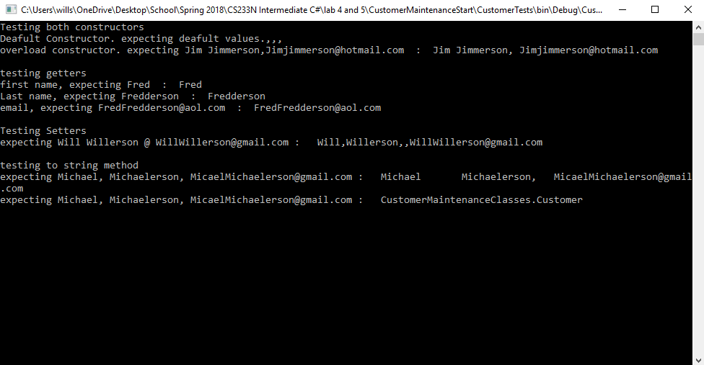
namespace CustomerTests
{
class Program
{
static void Main(string[] args)
{
TestCustomerConstructors();
TestCustomerGetter();
TestCustomerSetter();
TestToString();

Console.WriteLine();
Console.ReadLine();
}

static void TestCustomerConstructors()
{
Customer c1 = new Customer();//deafult constuctor
Customer c2 = new Customer("Jim", "Jimmerson", "Jimjimmerson@hotmail.com");
Console.WriteLine("Testing both constructors");
Console.WriteLine("Deafult Constructor. expecting deafult values." + c1.GetDisplayText(","));
Console.WriteLine("overload constructor. expecting Jim Jimmerson,Jimjimmerson@hotmail.com : "+c2.GetDisplayText(" "));
Console.WriteLine("");
}
static void TestCustomerGetter()
{
Customer c1 = new Customer("Fred", "Fredderson", "FredFredderson@aol.com");
Console.WriteLine("testing getters");
Console.WriteLine("first name, expecting Fred : " + c1.FirstName);
Console.WriteLine("Last name, expecting Fredderson : " + c1.LastName);
Console.WriteLine("email, expecting FredFredderson@aol.com : "+c1.Email);
Console.WriteLine("");

}
static void TestCustomerSetter()
{
Customer c1 = new Customer("Matt", "Matterson", "MattMatterson@gmail.com");
Console.WriteLine("Testing Setters");
c1.FirstName = "Will";
c1.LastName = "Willerson";
c1.Email = "WillWillerson@gmail.com";
Console.WriteLine("expecting Will Willerson @ WillWillerson@gmail.com : " + c1.GetDisplayText(","));
Console.WriteLine("");

}
static void TestToString()
{
Customer c1 = new Customer("Michael", "Michaelerson", "MicaelMichaelerson@gmail.com");
Console.WriteLine("testing to string method");
Console.WriteLine("expecting Michael, Michaelerson, MicaelMichaelerson@gmail.com : " + c1.ToString());
Console.WriteLine("expecting Michael, Michaelerson, MicaelMichaelerson@gmail.com : " + c1);

}

}
}

public class Customer
{
private string firstName;
private string lastName;
private string email;

public Customer() { }

public Customer(string firstName,string lastName,string email)
{
this.FirstName = firstName;
this.LastName = lastName;
this.Email = email;
}
public string FirstName
{
get
{
return firstName;
}
set
{
firstName = value;
}
}
public string LastName
{
get
{
return lastName;

}
set
{
lastName = value;
}
}
public string Email
{ //can just do get;set;
get
{
return email;

}
set
{
email = value;
}
}
public string GetDisplayText(string sep)
{
return FirstName + sep + lastName + "," +sep+ email;
}
public string ToString()
{
return GetDisplayText("\t");
}

Card Problem
Completed Card Class?  - Instance variables are camelCase and private?  - Implements all properties/methods in the specification? Implements both property get and set where appropriate? Property/Method names are TitleCase? Properties/Methods are public?  - Completed Card Tests? Tests all properties and methods in the class? Screen shot is included?  - Created a class diagram in visual studio? Screen shot included?  - Source code includes Card class as well as test program? | Yes  Yes  Yes  Yes  yes
One thing that you learned from writing and testing the class:
I learned about creating a card class library and linking it to another form.
Something that you’d like to continue working on:
I had a lot of issues with setting up a blank form and linking it to my class library, that Kaiser did not have. I think I may have taken a wrong step in my setup and I would like to figure out how to do it correctly.

Time you spent completing and testing the class:
Because of the afore mentioned issues with my form I spent between 2 and 3 hours working on this.

Class diagram, screen shot of testing, source code for testing and class:
Card Class
Fields: | Properties: | Methods:
suit | Suit | GetDisplayText()
cardValue | CardValue | IsAce
 |  | IsSpade
 |  | IsFaceCard
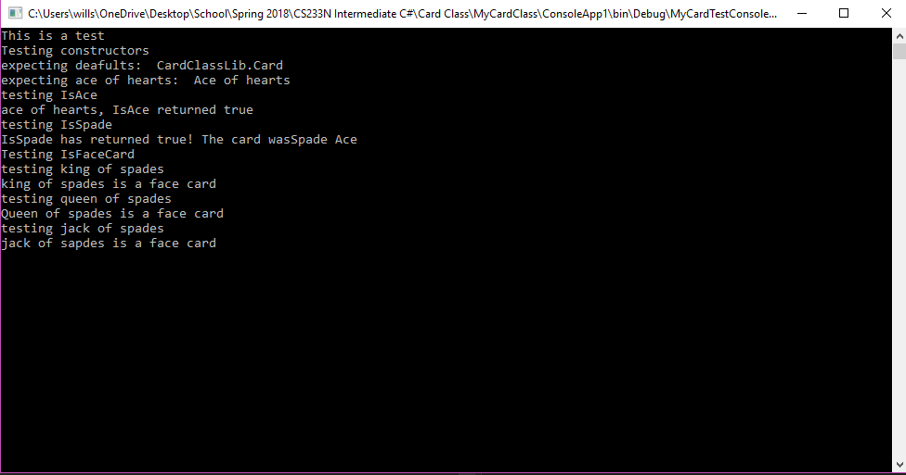
namespace CardClassLib
{
public class Card

{
private string cardValue;
private string suit;

public Card() { }

public Card(string suit1, string cardValue1)
{
cardValue = cardValue1;
suit = suit1;
}
public string Suit
{
get
{
return suit;
}
set
{
suit = value;
}
}
public string CardValue
{
get
{
return cardValue;
}
set
{
cardValue = value;
}
}
public string GetDisplayText(string sep)
{
return cardValue + sep + "of" + sep + suit;
}
public bool IsAce(string cardValue)
{
if (cardValue == "Ace")
return true;
else
return false;
}

public static bool IsSpade(string cardSuit)
{
if (cardSuit == "Spade")
return true;
else
return false;
}
public static bool IsFaceCard(string cardValue)
{
if (cardValue == "King" || cardValue == "Queen" || cardValue == "Jack")
return true;
else
return false;

}
}
}
class Program
{
static void Main(string[] args)
{
Console.WriteLine("This is a test");
TestCardConstructors();
TestIsAce();
TestIsSpade();
TestIsFaceCard();

Console.ReadLine();

}
static void TestCardConstructors()
{
Card c1 = new Card();
Card c = new Card("hearts", "Ace");
Console.WriteLine("Testing constructors");
Console.WriteLine("expecting deafults: " + c1);
Console.WriteLine("expecting ace of hearts: " + c.GetDisplayText(" "));
}

static void TestIsAce()
{
Card c = new Card("hearts", "Ace");
Card c2 = new Card("hearts", "King");
Console.WriteLine("testing IsAce");
string value = c.CardValue;

if (c.IsAce(value) == true)
{
Console.WriteLine("ace of hearts, IsAce returned true");
}
else
Console.WriteLine("something went wrong...");
}
static void TestIsSpade()
{
Card c = new Card("Spade", "Ace");
Console.WriteLine("testing IsSpade");
string suit = c.Suit;
if (Card.IsSpade(c.Suit) == true)
Console.WriteLine("IsSpade has returned true! The card was" + c.Suit + " " + c.CardValue);
else
Console.WriteLine("Something went wrong...");

}
static void TestIsFaceCard()
{
Card c1 = new Card("Spade", "King");
Card c2 = new Card("Spade", "Queen");
Card c3 = new Card("Spade", "Jack");

Console.WriteLine("Testing IsFaceCard");
Console.WriteLine("testing king of spades");
if (Card.IsFaceCard(c1.CardValue) == true)
Console.WriteLine("king of spades is a face card");
else
Console.WriteLine("Something went wrong...");

Console.WriteLine("testing queen of spades");
if (Card.IsFaceCard(c2.CardValue) == true)
Console.WriteLine("Queen of spades is a face card");
else
Console.WriteLine("Something went wrong...");

Console.WriteLine("testing jack of spades");

if (Card.IsFaceCard(c3.CardValue) == true)
Console.WriteLine("jack of sapdes is a face card");
else
Console.WriteLine("Something went wrong...");
}

}
}

Programming style for all programs
Is proper indentation used? Is each property/method indented properly? Is each control structure indented properly? | Yes
Are comments used appropriately? | I don’t think I added any comments this time
Do variable names use camel case? (camelCase for example) | Use
Do property/method names use Title Case (or Pascal Case?) | use

General comments and notes from the evaluator:

One thing that you learned from completing the evaluation:
I liked Kaisers use of just get; and set; as opposed to the longer way I wrote it. Also some of his code looked a lot my concise and practical.
Screen Shots and Source Code

